# NodsJS - introduction

**NodeJS famous and popular server technology that let us write server code in javascript.**

**It's designed to be able to use JavaScript to write server code.**

Don’t Imitate , Uderstand !

## CLI – Command Line Interface

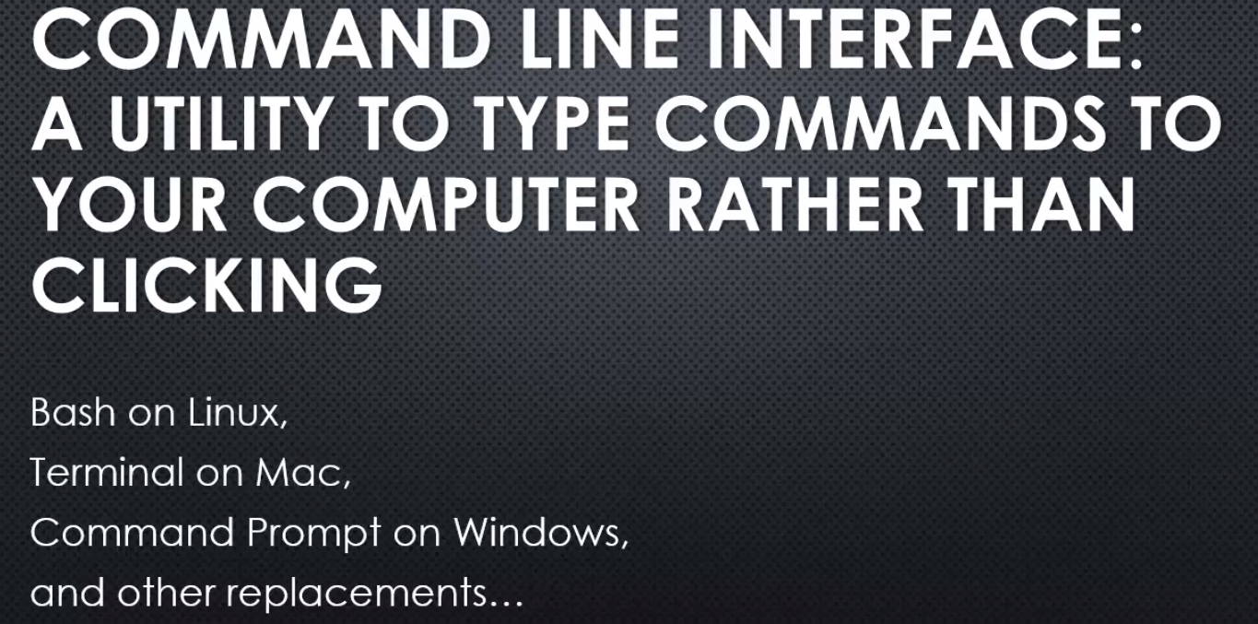

You type in a command,you type in programs that you want to run, and they run. Rather than clicking around with your mouse. And actually this is the way that things used to be. Computers didn't always have graphical user interfaces or GUIs,

Now sometimes the command line interface will provide commands that help a little bit visually.

For example I can put dir /w. That is an argument. Arguments are values you give your programme that affect how it runs.

But the argument will then affect what the programme does. The programme might say if you give me this argument, I'll behave this way or a different argument and I'll behave a different way.

Using the command line interface is about knowing the commands, knowing the programme, and all of the arguments that it takes. And then how you can string those commands and arguments together to do what you want.

# V8 : The Javascript engine

The thing at the heart of Node JS is The V8 Javascript engine.

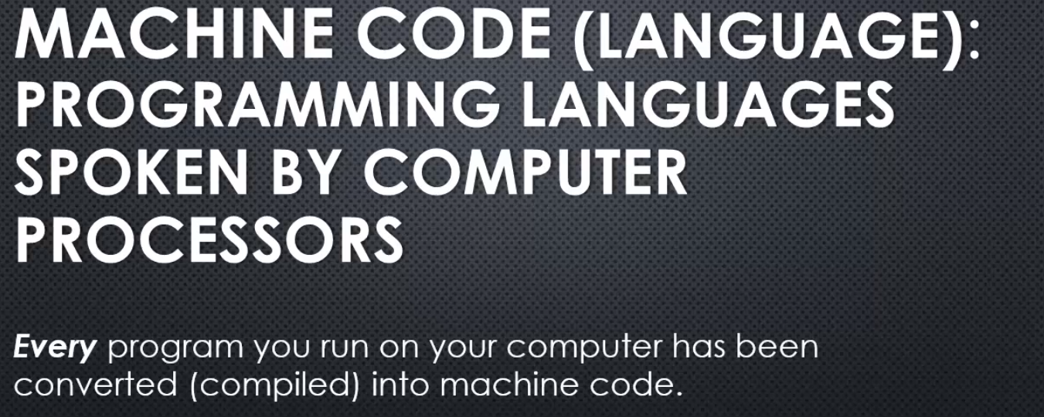

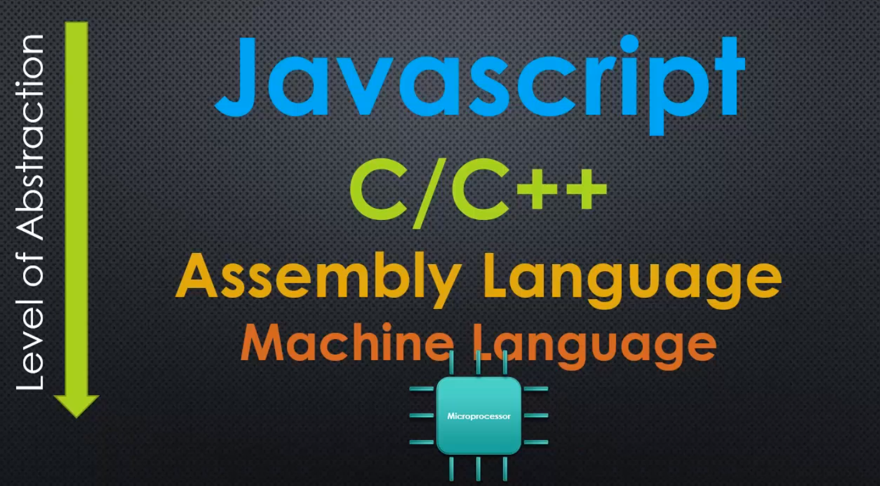

There have been levels of abstraction added to us, that get us to this modern era of computer programming.

So there's things like assembly language that came later. That is still pretty close to machine language but a bit easier to understand and read.

And then there a huge era of C and C++ and that really took off. C and C++ is still used heavily today but it's syntax, if you see,

it looks a bit more like Javascript or Java. Because Java and Javascript were inspired by what's called, C syntax that is the way C and C++ programmes look when they're written. Things like curly braces and functions

but C and C++ still lets you have a degree of control that's lower-level. And so a bit closer to the microprocessor itself. And that's why it's very popular to use, because you have a great degree of control but it's easier to code in than assembly or machine language.

And then you have programming languages, very high-level programming languages like Javascript, which are very far removed from the computer's processor.

**We don't deal directly deal with where memory is and what it's doing.**

**You have an engine between you and the microprocessor that's taking care of all those things for you.**

So when we're talking about writing Javascript we're really talking about writing a programming language that some other programmes are going to convert into something like machine language.

Perhaps Javascript gets converted directly to machine language, but nonetheless, something is going to do that work.

So we sit very high in these levels of abstraction as modern developers in web development. We sit very far away from the microprocessor.

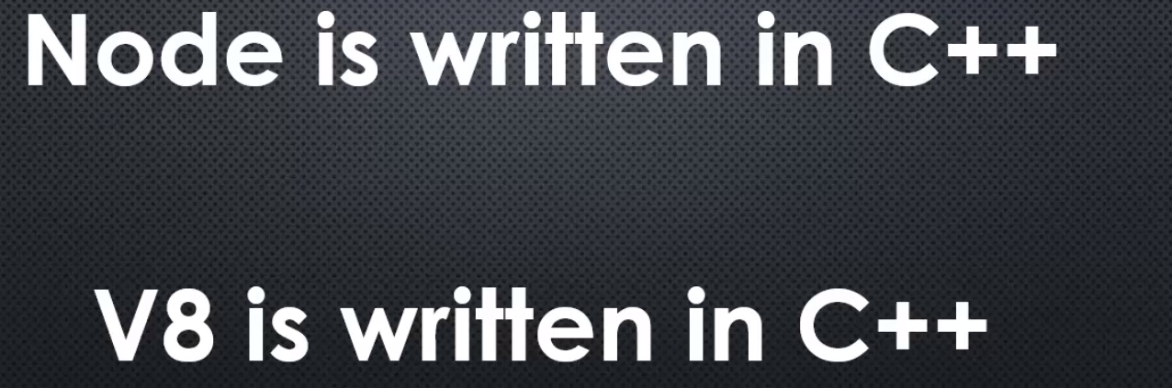

Node is written in C++.

Now you might be thinking, "whoa, wait a minute,

everything I see about Node and when I'm trying to learn Node JS, is about Javascript.

When I'm writing Node, I'm writing Javascript." Well that's true, you're writing in Javascript. We write in Javascript when we write Node programmes but Node itself, is written in C++, it's a C++ programme.

**the reason why Node is a C++ programme, is written in that programming language, is because V8 the Javascript engine is written in C++.**

**V8 the thing that converts Javascript to machine code, is written in C++. And so Node, which adds onto it, is also written in C++**

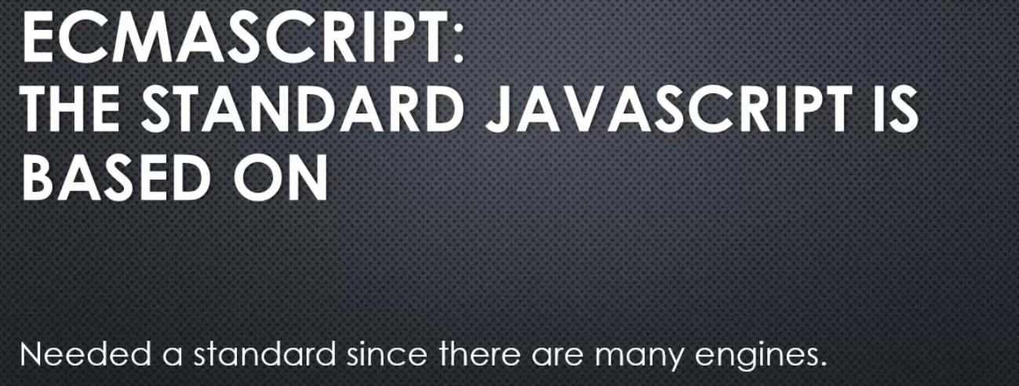

JavaScript was invented first, but then different browser makers, like Microsoft, Netscape,

they started making their own JavaScript engines and their own little tweaks, and changes, and differences between them.

**ECMA is an organisation that basically is a standard organisation that says, "Hey, let's try and say exactly how something should work."**

And so **ECMAScript is the name for the core standard that JavaScript itself bases itself on.**

And we needed that standard because there are many engines out there. V8, which Node.js is built on top of, is actually just one of many JavaScript engines.

So, when we are talking about JavaScript and we are talking about ECMAScript, you can basically think of them as the same thing,

but JavaScript is the actual language that we are writing, and ECMAScript is the standard that says how the language should work, it's a core scripting language standard.

All right, but for the purposes of our discussion they are essentially interchangeable terms.

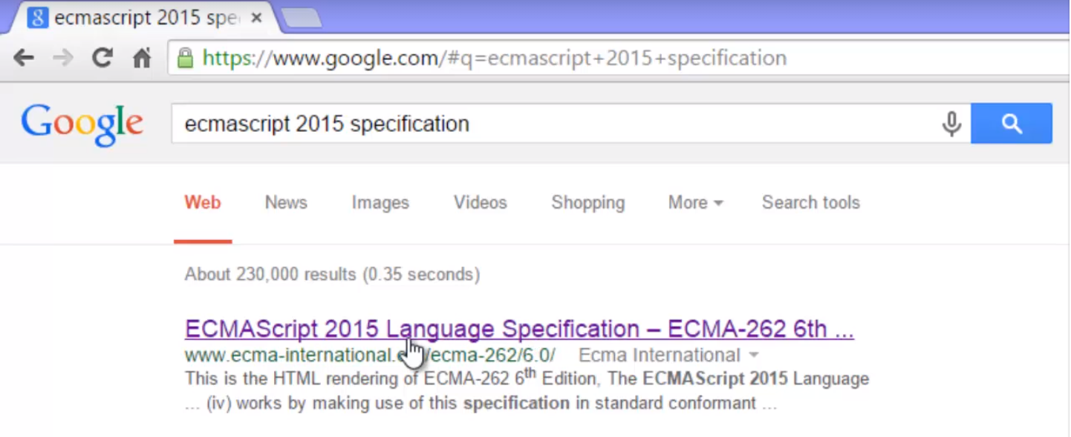

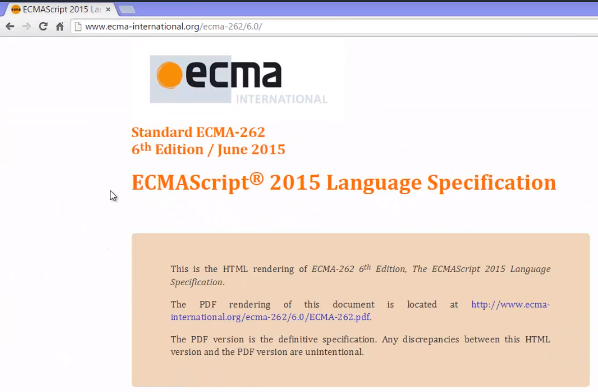

If you look at the specification and were to go down through it, you'd see all sorts of things that JavaScript is supposed to have and supposed to do.

It describes its behaviour, it describes exactly what should be expected when certain things are done in the language, and therefore is the standard upon which JavaScript engines should be based.

**In other words, if you were to write your own JavaScript engine, what you cause JavaScript code to do should match the specification.**

V8 does that.

**V8 makes sure that the JavaScript code that is written, the machine code that it's translated to does what the specification expects it to do. And the specification is just a standard that everyone has agreed upon, this is the way JavaScript should work**

Java script Engine - 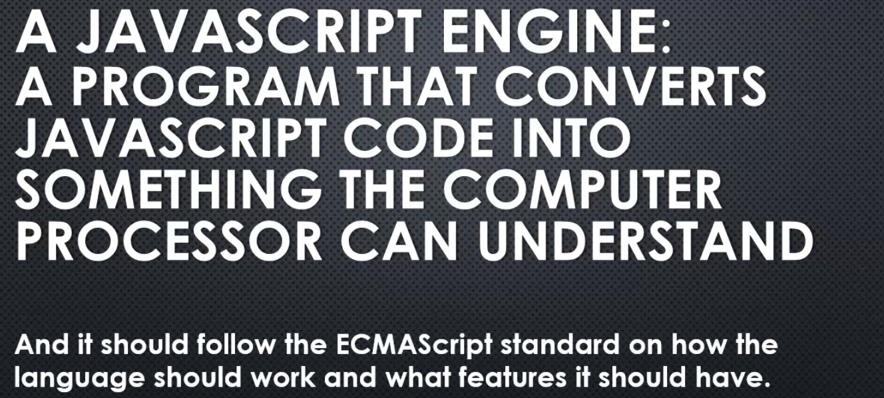

**V8 is a JavaScript engine, and it sits at the core of Node.js.**

**V8(JavaScript engine)-** Google's V8 engine is open source. It's available to look at, to use, and to even change for your own purposes.

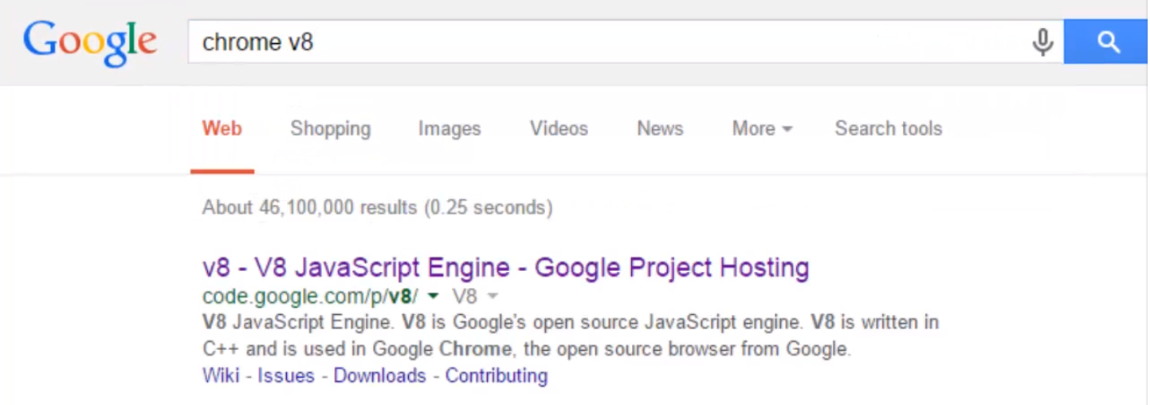

I searched for Chrome V8 because **V8 was primarily written to be used inside the Google Chrome browser, and it certainly is.**

**However, it's also built in a way that let's it be used elsewhere, and in other ways.**

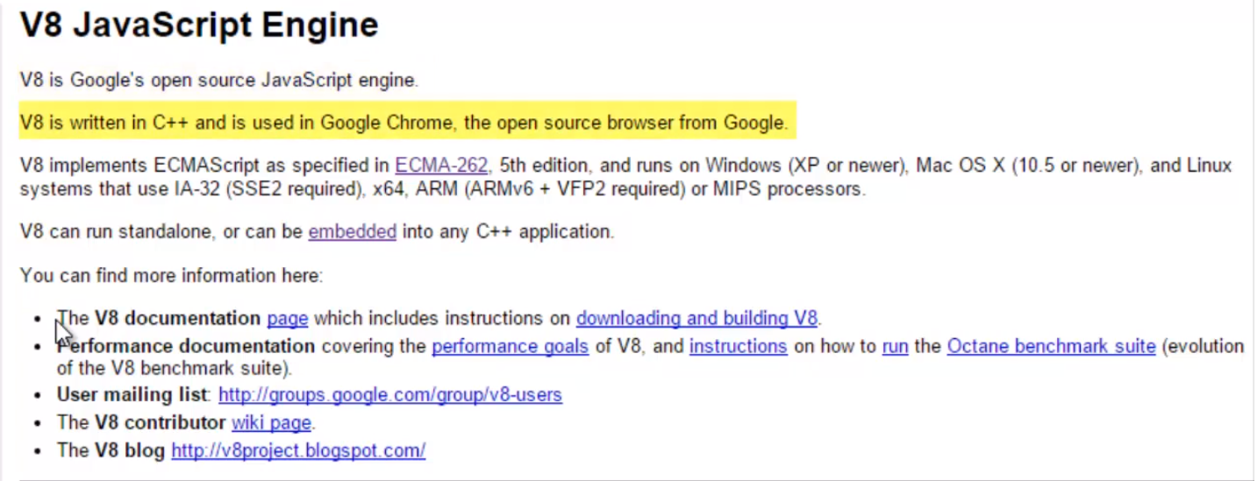

go to source and then click the link, there's a Git repository, a source code repository, that is to say, there's a spot where all the source code of V8 lives, and I can go grab it free of charge.

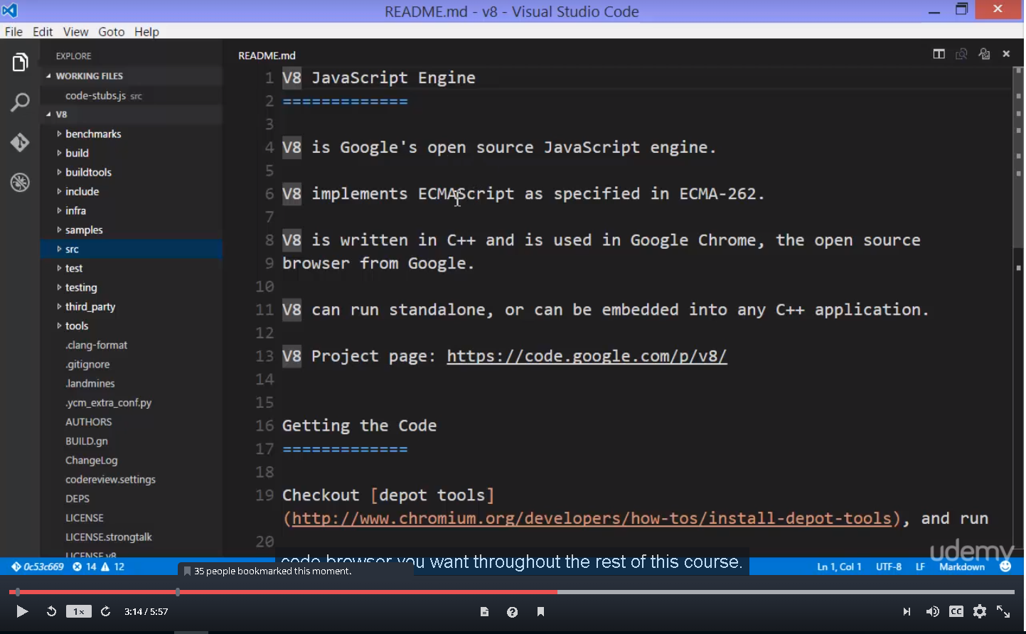

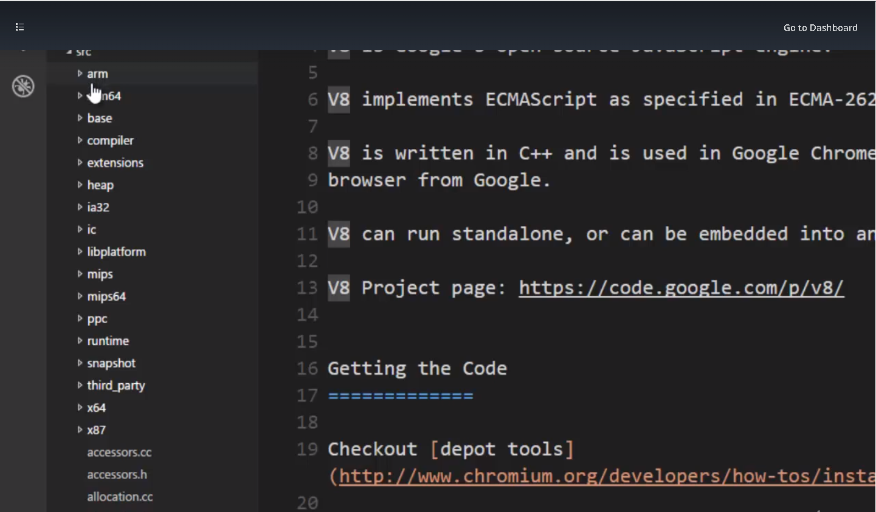

If I open this source folder, the src folder, you already see some things that we might've seen before:

ARM,IA32,x64,

there's entire sets of code for each of the machine languages that V8 supports. so we can convert Javascript into any one of these languages

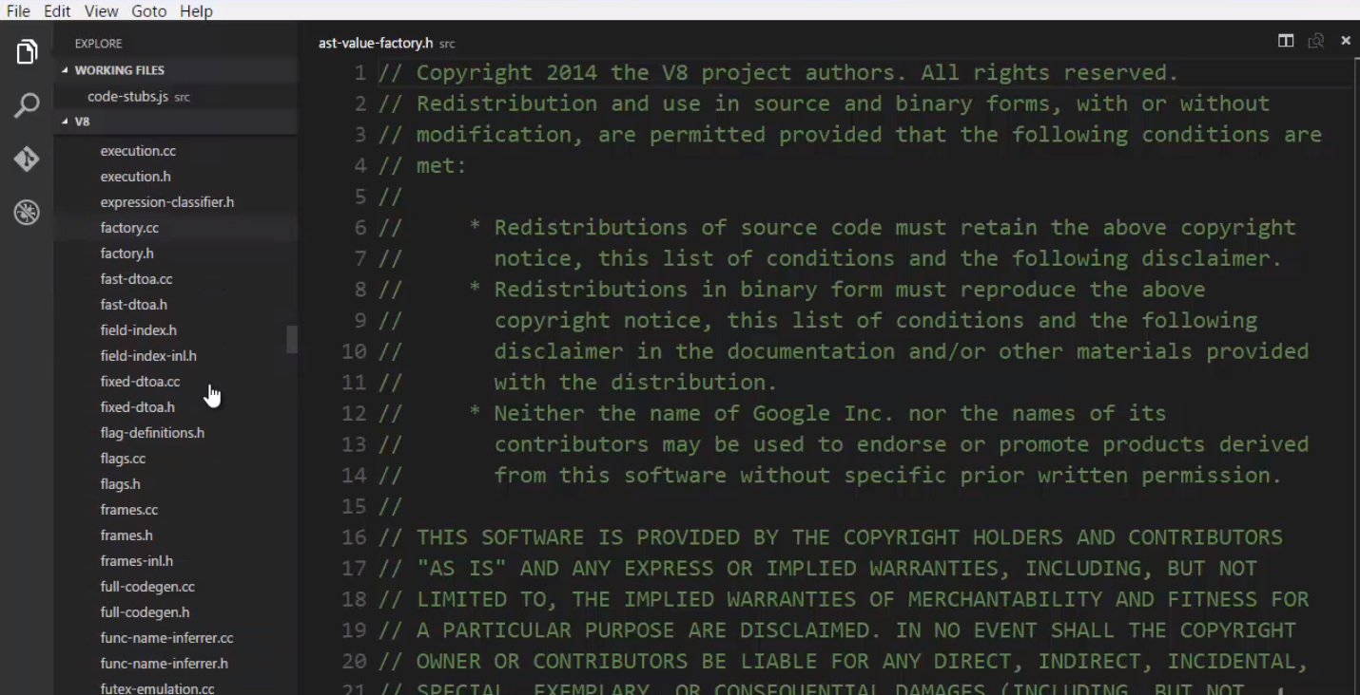

**and it's more than that, inside there's a huge number of .h and .cc files, .cc is a C++ file, and .h is also a part of the C++ language.**

**All of this code, all of this C++ has to do with implementing the ECMAScript standard.**

**This is the engine, this is the engine's code that will read Javascript, the text of Javascript,**

**and convert it into machine code, and it's a lot of code.**

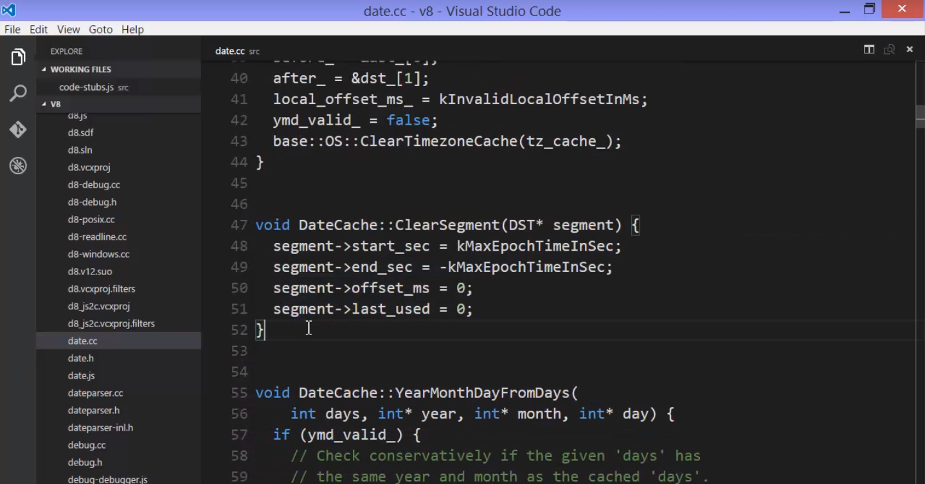

**there's a date .cc file that deals with dealing with dates. Javascript has to deal with dates, and so there's code written in C++, and notice this looks a little bit like Javascript. and this engine is gonna convert what you write in Javascript to something that the computer processor can actually run.**

So, this is code within the engine. V8 is huge. It's been worked on for years, and it's highly performant, it's really fast. And it's extremely useful, and it's free.

Open source, you can use it within your own programmes, and that's what we're going to see next.

But here we can see that V8 isn't some mysterious black box. It's just a lot of code. Code designed to do exactly what an engine is supposed to do, execute Javascript.

That is to say, convert Javascript code that you write, into something far more based, far lower, and in some ways, more complex.

# **The Node Core**

## **Conceptual aside – Servers and Clients**

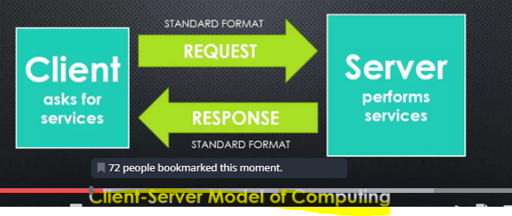

a server is a computer that is performing services. It's just a computer and it's performing jobs that are requested of it.

The client asks for those services, and the client may also do some work, but the server does the heavier, deeper amount of work.

**So the client makes a request for a service, for some work to be performed, and the server responds with perhaps verification that the work has been performed or error messages, or data, or other things. And that request is in some standard format that both the client and the server are programmed to understand. And so is the response also a standard format that both the client and the server are programmed to understand.**

So both the client and the server are computers. In fact, they may be the same computer

in some circumstances, but the client is asking for the work to be done, and the server is doing the work.

**This is called the client-server model of computing.**

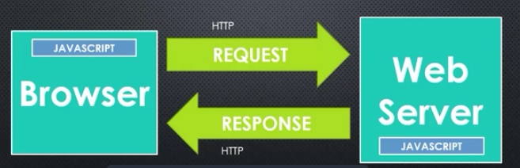

Now this standard model of request and response in a standard format between client and server exists in one of the most popular means of using this model, that is the **internet**.

So we are used to talking about a web server, that is a computer, connected to the internet, that is accepting requests for work, or data, and is then providing responses.

**The usual client is the internet browser, like Google Chrome or Internet Explorer or Firefox or Safari, and they communicate with the request and the response for that work to be done, for those services. And the standard format, on the internet, is called HTTP. There's an HTTP request and an HTTP response.**

For now though, **we're going to focus on the programming language that we use when writing web software on the client and on the server, that is the internet browser or the web server.**

If you've done any kind of front end web development, meaning coding in the browser, we use HTML and CSS for laying out our information and our web page, but if you've done any coding, you've likely done it in JavaScript, because that is the language that the browsers have standardised on.

browsers like Google Chrome, Firefox, Safari, Internet Explorer, Edge.

They implement a JavaScript engine of some kind, so that we can code in JavaScript.

**Now Google Chrome, for example, is a C++ programme. It embeds V8 and it makes extra features available to JavaScript within the Google Chrome browser.**

For example, if you've done some work with JavaScript, maybe using the jQuery JavaScript library editing DOM elements, that is, the HTML elements after they've been pulled into memory, editing the contents of the web page dynamically, or perhaps use AJAX and the XML HttpRequest object.

**If you've done any of those kinds of things,**

**you've done something that's outside the ECMAScript specification. If you look for DOM manipulation, you won't find it in the ECMAScript standard.**

**There's nothing about editing a web page, but those features are made available to JavaScript by, in this case that we're talking about, the Google Chrome C++ programme that is the browser. So this idea of giving JavaScript more features already exists.**

**If you've done any JavaScript coding in the browser, you're already using this idea of features that don't be default exist in JavaScript, but that are made available through JavaScript for you to do work.**

Now that said, the work that we're doing is client work and requesting services, requesting data from the web server.

Many times, in the real world environments, in real companies, you might have to do more than just one side of this coding work, not just the browser, not just the web server, but both.

So you may have been using PHP, or C# if you were using ASP.NET, or Ruby if you're using Ruby on Rails, or other programming languages that are used within particular web server technologies.

So you had to switch back and forth between two different programming languages at least, in order to get your work done.

But **the goal here, with Node.js, is instead to write JavaScript on the web server. So the web server still needs to do all these jobs and work, and just like the browser, we're going to use JavaScript. So you only need one programming language in your tool belt while you're building your software.**

And just like the browser, we can add on features to JavaScript to make available features to JavaScript that are useful for the work that needs to be done. For the browser, things like manipulating the DOM, manipulating the elements that appear on the web page,

for example.

On the web server, there's other things that need doing.

Now **this isn't the only reason why Node.js exists, to write server code in JavaScript, but it is a really great benefit that you can actually share libraries of code between the browser and the web server, and that you, and any others that work on whatever project you're working on, only need to worry about one programming language the entire time that you're writing code.**

## **What does Javascript need to have to manage a server?**

What are the features that we need to have accessible in JavaScript in order to do the kinds of things that a web server normally needs to do?

For example-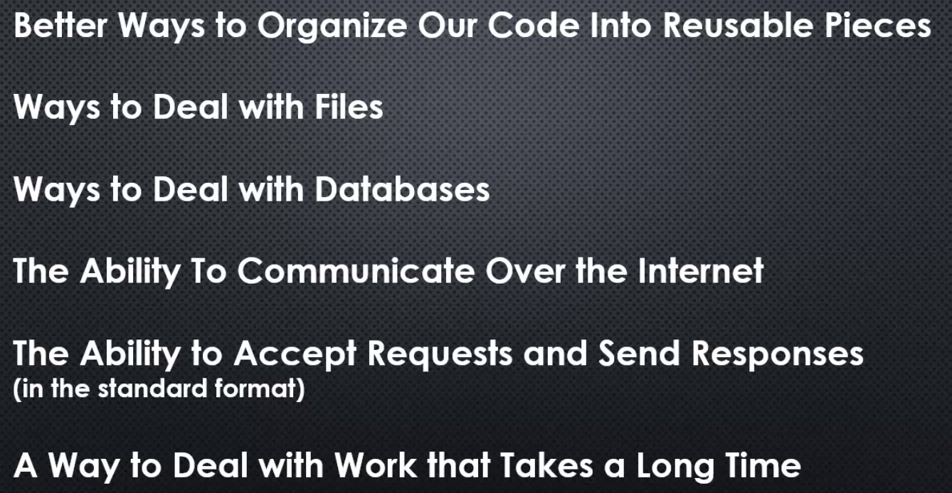

JavaScript needs better ways to organise its code into reusable pieces. As a developer, in other programming languages we have better ways to do this than JavaScript did for a long time.

Now, the new version of JavaScript ES6 actually has some better ways to do this

but Node.js was answering this question before that existed.

We also need ways to deal with files. If you're a web server, you're likely going to have to work with files, maybe zip files or images or other things along the way.

We need ways to deal with databases. You're almost always dealing with the database when it comes to building web software, and it's the web server that talks to the database.

We're a web server so we need the ability to communicate over the internet. JavaScript by default does not have that, you won't find it in the ECMAScript specification.

As a web server, we need the ability to accept requests and send responses in the standard format that's used in internet communication.

As a web server, since it's asked to do jobs, to do work, sometimes the things it's asked to do take a long time, and we want people to be able to continue to access the web server even when it's doing things that are taking a while. So, we need a way to deal with work that takes a long time.

**These are just some of the problems that need to be solved when you're designing a web server, and some of the things that JavaScript simply doesn't have out of the box, and these are the things, among others, that Node.js solves for us.**

## The C++ Core

**The first part of the node core, the core code that makes up node.js is The C++ core, the area of node.js that's about adding the features, about building the base, the foundation of what makes node.js, a web server.**

Let's take a quick look at the node.js source code.

To begin with, we'll go to github.com/nodejs/node.

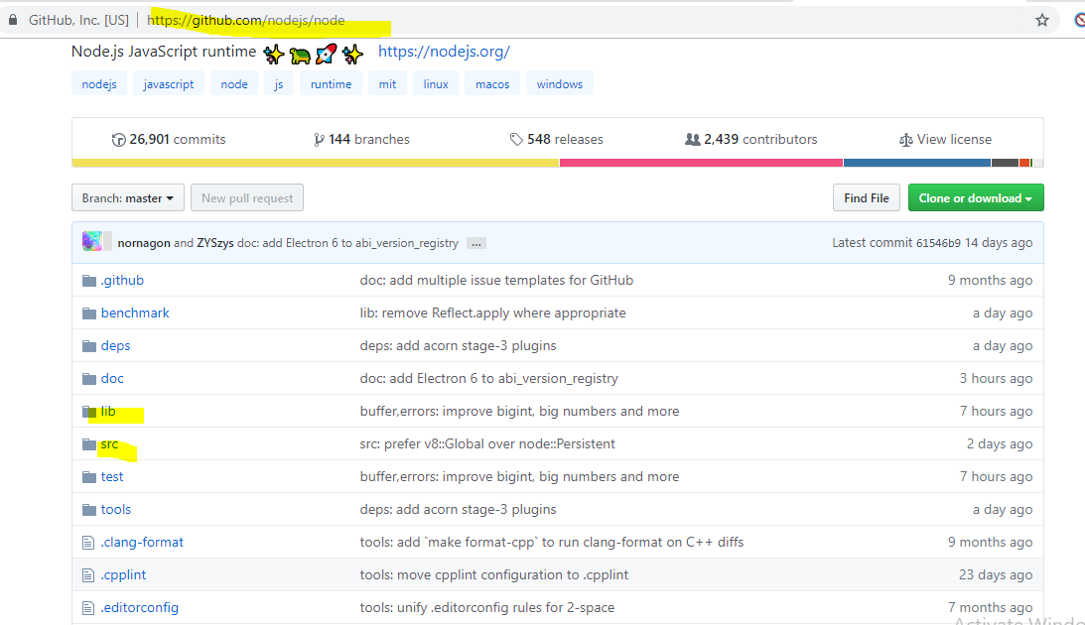

it's full of code, files and folders.

I just want to show you, what's going on behind the scenes with node.js.

Node was created by a guy named Ryan Dahl, while working at a company called, Joyent, and they're still involved in node.js and its development. However, node.js has since become more open source structured, so that there's a foundation that's actually working on node.js itself.

Lets have a quicker look at NodeJS source code –

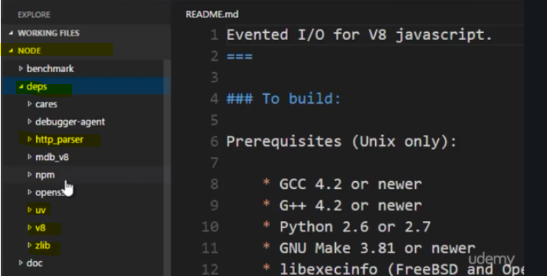

There are a few folders of interest, within all of this code.

we'll start with deps, deps or dependencies, **that's things that were built outside of node.js, but are a part of node.js.**

**For example, the obvious one, v8, Google's v8 JavaScript engine, that's part of node.js.**

**These are the things like uv, this is libuv or http parser, we'll see that as well.**

**So, there are other libraries that are built into node.js and some are built specifically for node.js, and these are C++ libraries of code.**

**Like zlib for example, this is for creating and using zip files.**

Then, there's the src folder, which is the C++ source code, and there's quite a lot of it.

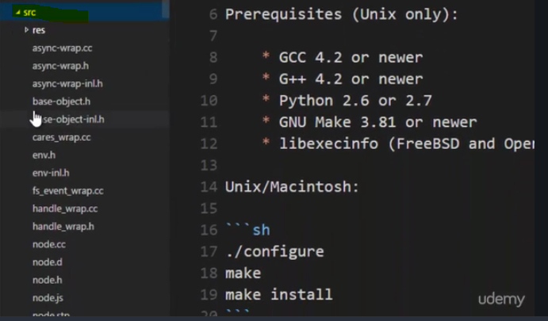

if I go to node.h, one of the first lines of code, is what we were to inspect, we're embedding v8. **We're using the v8 engine throughout node.js, to process and execute JavaScript code.**

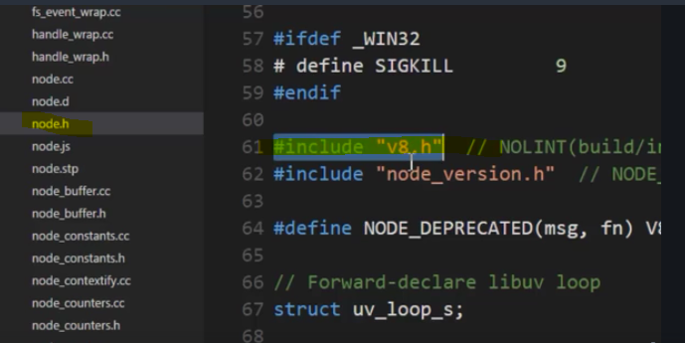

And of course, there's a lot more going on in C++ programme,

**So, the C++ core, is a core of features of utilities built in C++, made available to JavaScript via the hooks in the v8 engine.**

So, we can see that there's plenty going on in here

Most of these things you can find in the node.js source code as far as actual usage, as far as actually what they do. But we can see and understand and get a feel for the fact that there's

an awful lot of features that node.js is adding to JavaScript, making available to JavaScript.

**The mental model you should have, is not that node.js is JavaScript, but rather that node.js accepts JavaScript and allows to have more features that we write with it than normal.**

## **The Javascript Core**

While the C++ core is one side of Node.js,

there is another side,

the JavaScript side of the core.

**There is plenty of C++ utilities within Node.js, however, there is actually just pure JavaScript that's been written for you to help making using those C++ features easier, as well as also some other common tasks and needs that you commonly have in JavaScript development that's also made available for you within Node.js that comes along for the ride when you install Node.js.**

we're again in the nodeJS source code.

This time we'll focus on the folder called **lib** .

And notice, instead of being full of C++ code, it's full of JavaScript files.

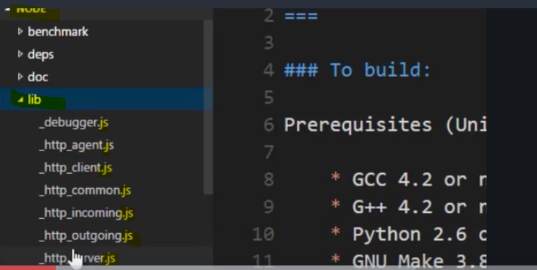

Why?

**Because Node.js also comes with a large amount of JavaScript written for you to perform tasks, and most of these are actually wrappers for the C++ features.**

For example, remember that zlib was for dealing with zip files in C++ core.

Well, if I open this zlib.js, if you were to open up these JavaScript files, you'll find very often this kind of line right here called process.binding, and what process.binding does,

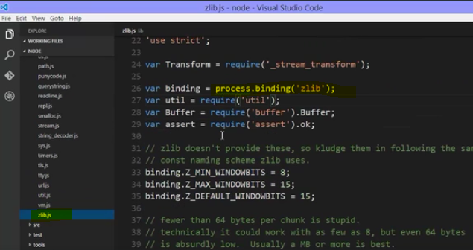

**it's a feature that essentially goes out and grabs the C++ feature, and makes it available inside the JavaScript, so this is essentially going out and getting the zlib C++ object, and then it's being used the rest of the time here in this JavaScript code,**

**so when you use zlib, you're not actually going out and grabbing the C++ library, you're using the JavaScript library that wraps the C++ feature for you. It makes it easier to use and add some features.**

So,

Node has gone out of its way to make sure that you can use all of the extra features that it has created and added for you, as easily as possible.

**However, not all of the JavaScript code in here is about wrapping the C++ features.**

**Some things like util.js is just a bunch of functions that are useful, things that you could have written yourself in JavaScript but they've written for you, the kinds of things that you might do often.**

we can see that Node is a framework and also a library of code, and we have a baseline to help us to make it easier to write our own JavaScript, and we can learn how to use all of these utilities, features and functions.

## **Lets install and write some javascript in Node**

To begin with, we need to instal Node JS.

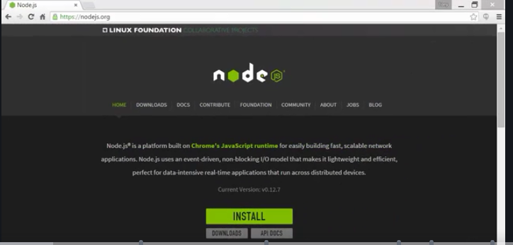

**It also installs something called NPM.**

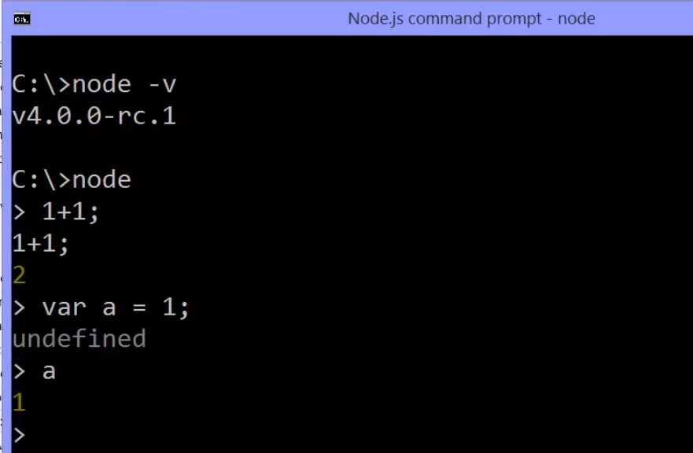

idea being that you can run the Node command no matter what folder or file you're looking at in the command line interface, that Node has just become a command that you can use.

For example, in Windows you might have added Node to your path variable, which means it's available everywhere

We're going to write some JavaScript in Node.

**All you have to do is type the word Node in your computer, in your command line interface, That will start a command line interface programme that comes along for the ride with Node, where I can simply type JavaScript into the command line and get the output back after it's been processed through the V8 engine in Node.**

So for example I can say one plus one, and I get back the response two. This is a lot like that little programme that we looked at before.

**This JavaScript got passed into Node, Node passed it through the embedded V8 engine, as well as whatever extensions that it added to the V8 engine, and we got our response back** from that code being executed.

**Running a js file in node.**

to do my actual coding I'll be using Visual Studio Code. You can find it at code.visualstudio.com. It's a Microsoft programme but it works on Linux, Mac, and Windows, **and it's designed for coding in a variety of languages, but the first and primary is JavaScript and Node JS development.**

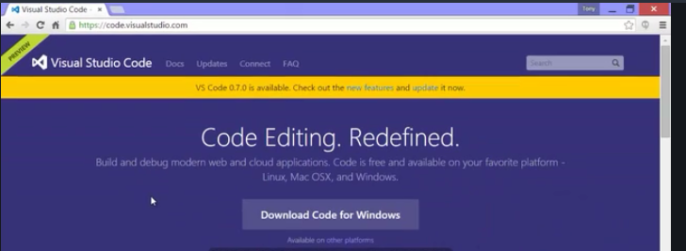

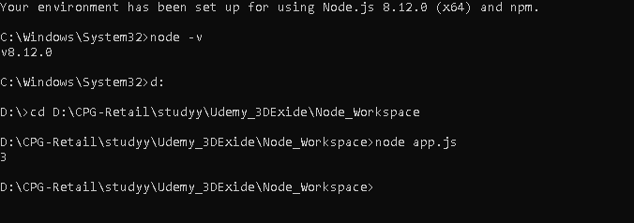

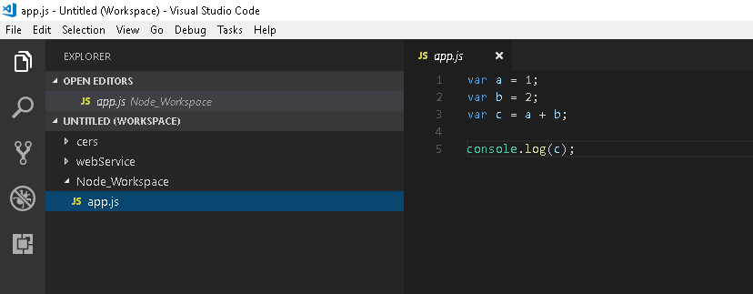

you may have used console.log. Which logs data values to the browser console, which helps when you're trying to figure out what's going on with your programmes.

Node JS was nice enough to provide the exact same concept, and they also called it console.log since we're so used to typing that perhaps as JavaScript developers. So I can console.log C, and this works the same as that print command that we saw in our other little programme. This will output the value to the command line window.

**Now to run app.js file**

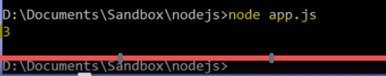

We need to point Node at one JavaScript file.

Now, in the next section we'll see how you can actually use multiple JavaScript files behind that single JavaScript file,

**but you're always going to give Node an entry point, a single JavaScript file that it will run, that it will execute**.

**With Visual studio code we can debug our node application also –**

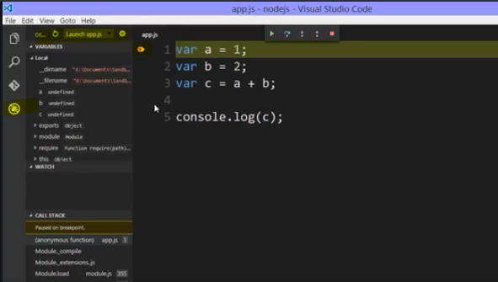



this is a good time for a side note about versions of Node JS.

You might be a little confused depending on which version of Node JS you've installed.

You may have seen, when you ran Node - V, something like this, a 0.12 point something. And that's fine, actually that version of Node, 0.12 point something, everything we do in this course, for the most part, will work just fine.

However you may have noticed that I was running something far higher. A four point something.

Why is that?

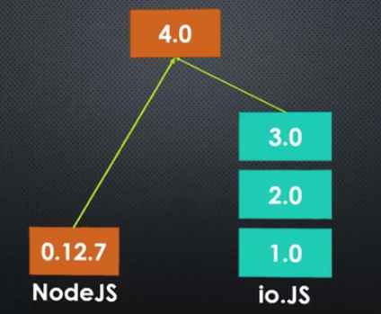

Well it has to do with something called io.JS. What basically happened was, Node was invented within a company called Joyent. But it was open sourced. And the people who worked at Joyent who originally worked on Node were unhappy with how often Node was being updated.

You see, Node depends on V8, the JavaScript engine as we've seen, and V8 is being updated by Google, not by Joyent or the people working on Node. So, as new versions of V8 come out, you need to update the version of Node in order to be able to use the newest and latest version of the V8 engine, as V8 makes changes and as it adds features and as it adds the new features that are coming in the next version of JavaScript.

So, because of this there was a split.

Node JS is an open source piece of software, and so, those that really wanted Node to be built and updated faster split their own version and called it IO. So, they actually continued to work on this, version one and version two and version three, and then at long last, Joyent and the people working on IO came to an agreement about how Node should be structured and updated from a clerical standpoint, and so now, in fact right now, as this particular lecture is being recorded, a new version of Node is being released that merges Node JS and IO, and merges the changes that were made in IO, all the updates, the latest version of the V8 JavaScript engine, et cetera,

and to not cause confusion with the version numbers, the latest version of Node, as of the recording of this lecture is 4.0. And this is happening, as I said, right now as this lecture is happening.

So, you may be using version 0.12, or if you're watching this particular course a few months from now, you may already just have version four point something installed. So that's fine, again either one of these will work for the most part for everything that we see in the course, but as future versions of Node come out, that also means you're dealing with a later version of the V8 engine which means more JavaScript features, updated JavaScript features, are available to you.